**CI-103 Design Project**

DON’T SEE

### **User Manual**



Minh Pham

Linda Zhang

Hangyu Li

Kiruthik Sai

Revised on:

06/06/2019

**USER'S MANUAL**

**TABLE OF CONTENTS**

Page #

A. GENERAL INFORMATION........................................................................................... A-1

1.1 About the Game............................................................................................................ A-2

1.2 Project References........................................................................................................ A-3

B. GETTING STARTED..................................................................................................... B-1

3.1 Opening the game........................................................................................................ B-1

3.2 Menu............................................................................................................................. B-1

3.2.x Navigation..................................................................................................................... B-1

3.4 Mini Games.................................................................................................................. B-1

C. Handling errors.............................................................................................................. C-1

4.x Start errors.................................................................................................................... C-1

4.x.y In-Game errors.............................................................................................................. C-1

4.2 Game Crashing............................................................................................................. C-1

4.3 Game stuck in a loop.................................................................................................... C-1

D. FAQs............................................................................................................................. D-1

E. Contact Us.................................................................................................................... D-2

6.1 Email…………………………………………………………………………………………...

6.2 Open Github Issue Request…………………………………………………………...……..

1. General Information

### About the game:

This game is developed on unity with giving main priority to accessibility and entertainment. This is a developed and designed in a three month time-frame for a Computing and Informatics class at Drexel University.

The purpose of developing the game is to give visually impaired people, more accessibility to games while learning and having fun.

**Technology/Platforms Used:**

Unity v.2019- Game Development VS code v.2017- Script and code development

 

**Created By:**

Minh Pham -

Linda Zhang - Product Owner

Hangyu Li-

Kiruthik Sai - Mini Game Developer

### Project references:

1. <http://brackeys.com/> - Unity Game Development tutorials



1. <https://unity3d.com/learn/beginner-tutorials> - Beginner tutorials



1. <https://catlikecoding.com/unity/tutorials/>- Introductory C# and Unity tutorials



1. [https://www.freecodecamp.org](https://www.freecodecamp.org/)- Basic C# coding and mini game development.

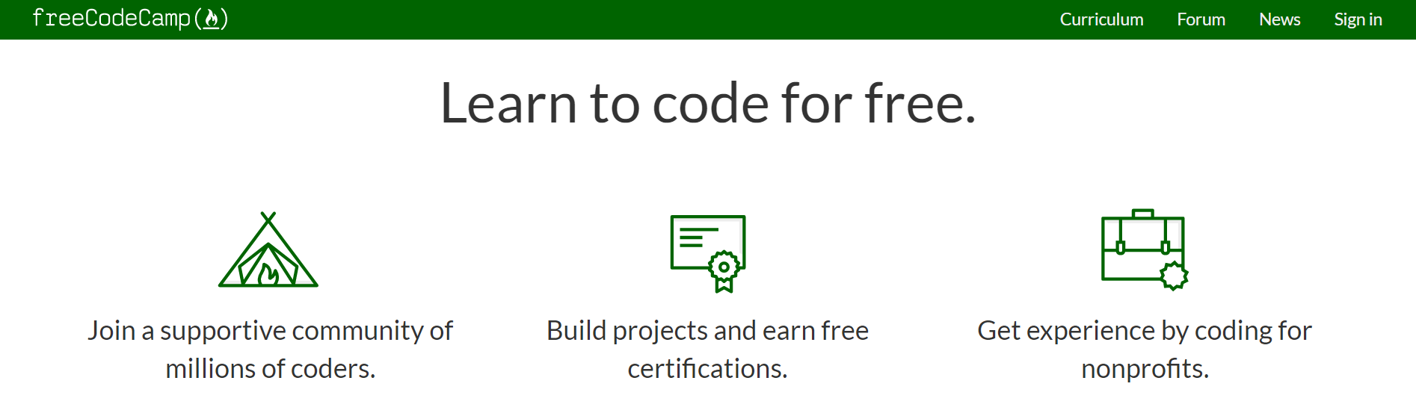

1. Getting started

### Opening The Game

* Open where you store the game
* Open the MazeGame.exe

### Menu

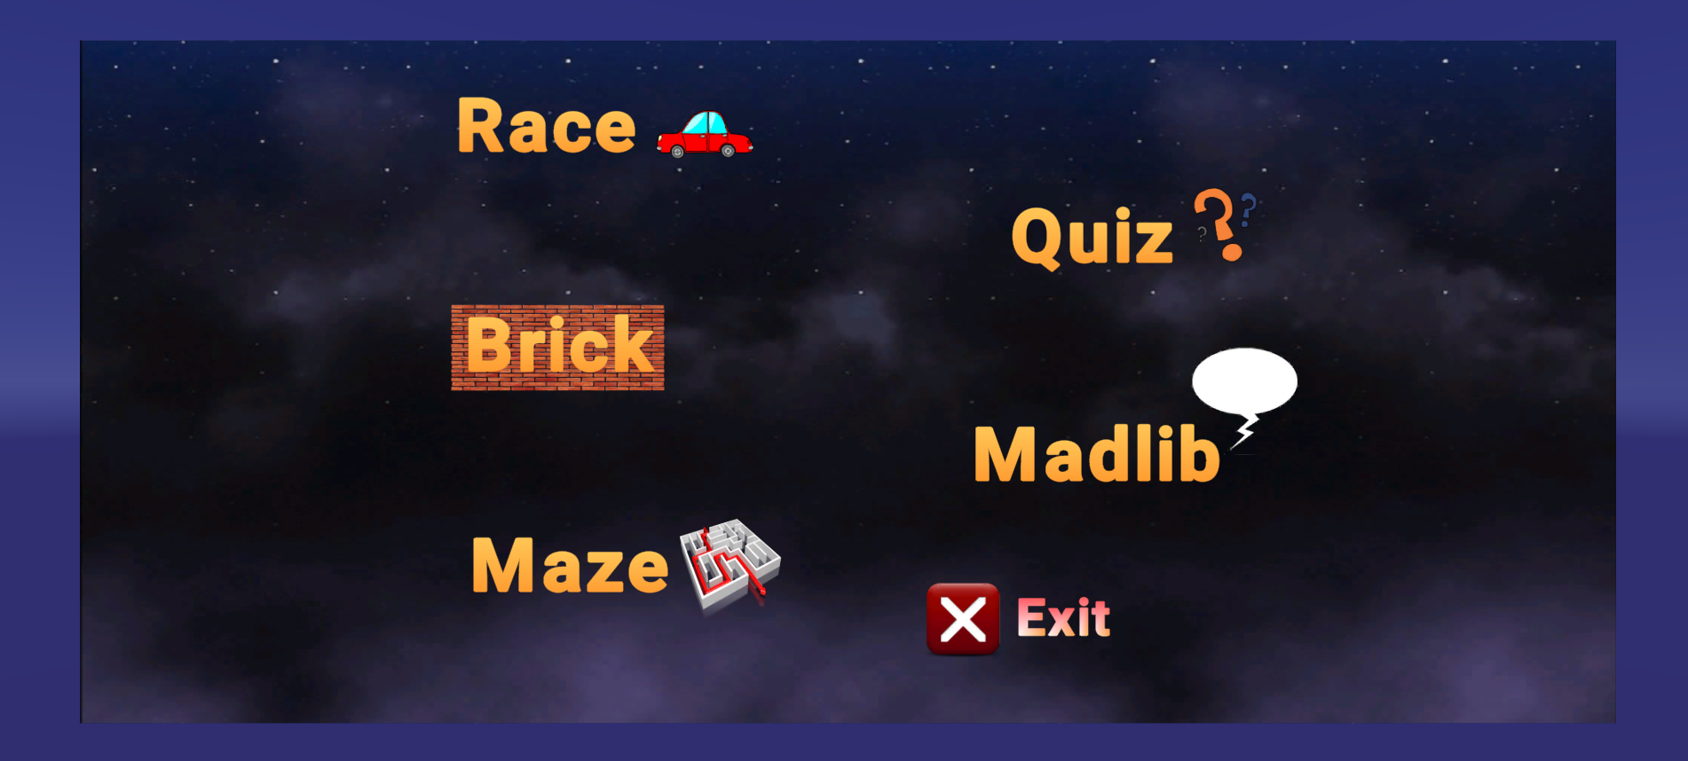

* Hover over to the game you want to play and left click on the mouse to play

### Navigation

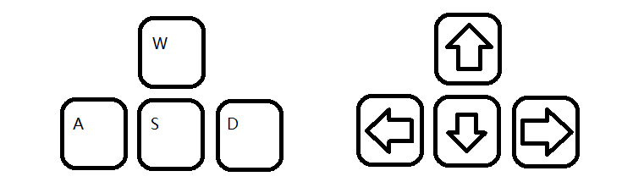

* Say help or press Space Bar for Help / Instruction
* Use the Arrow or W A S D keys to move the character around
* Use the mouse for rotation of the character
* Mouse right click for stopping the audio from playing
* Press the Escape button for any game to go back to the main menu

### Mini Games

I) Madlib

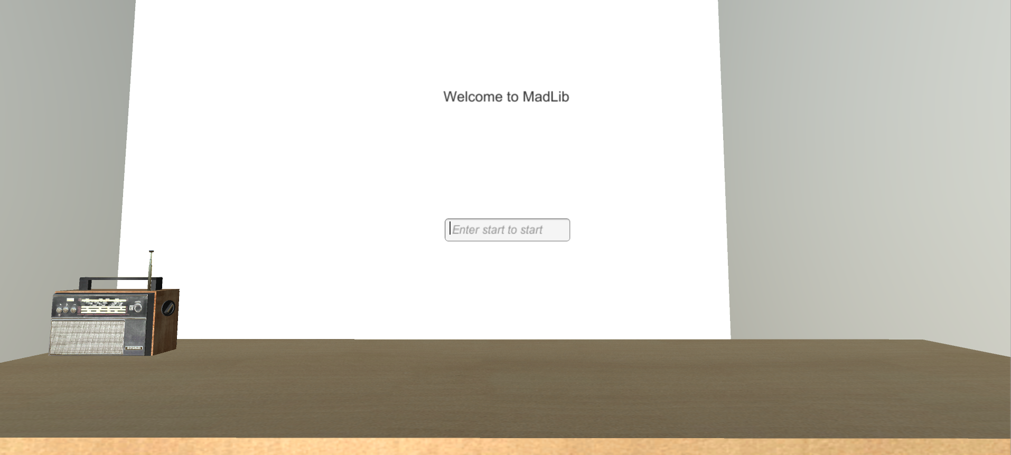

Objective: Fill out the textbox

Mouse left click - Disable textbox or enable textbox

Say or Type start to begin the game

Say or Press enter - Enter Next word

Say or Type clear or press shift - Clear the textbox

Extra: say chair to sit on chair

say sit to sit on a chair

say stand to get off from the chair

II) Racing



Objective: Reach the end without hitting the black blocks

* A or left arrow - move left
* B or right arrow - move right

III) Brick

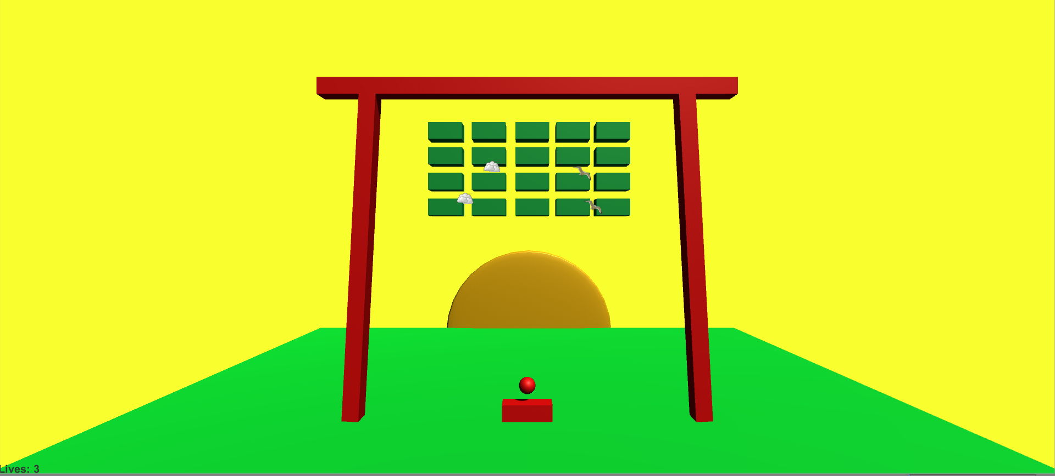

Objective: Hit all the bricks with the three chances of life

* Mouse click left - launch the ball
* Left Arrow or A - move left
* Right Arrow or D - Move right

IV) Quiz



Objective: Answer all the questions

* Left Arrow - True
* Right Arrow - False

C. Handling errors

### What are errors?

An error is a term used to describe any issue that arises unexpectedly that cause a computer to not function properly. Computers can encounter either software errors or hardware errors.

### Opening the game

If you’re unable to open the file, there may be several reasons behind this. While there may be system reasons behind it, here we’ll discuss some potential solutions to a very few common problems:

i) *When it shows administrative errors:*

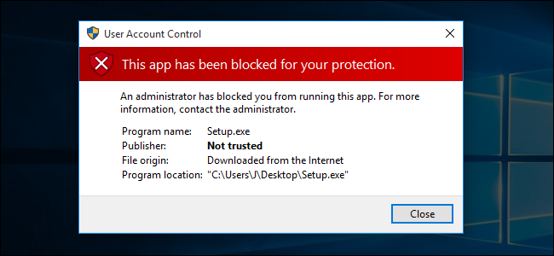

As our game is solely developed on a free version of unity and have had our own modifications, windows may recognize this application as an untrusted source. This may lead to blocking from firewall or administrative properties.

**SOLUTION:**

Run the program as administrator and disable firewall.

ii) *When Unity version is incompatible*

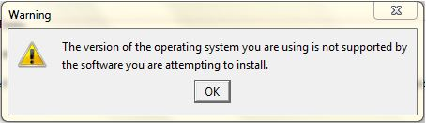

**SOLUTION:**

Unity has a very selective versions and some games may not run on the older versions, so if version-related errors pop up, make sure to keep your software updated.

### In-Game errors.

While we’ve put our utmost dedication and knowledge in making this game, there maybe some intricate flaws that will definitely come up as you play it. Some errors may just affect a little on the gameplay while, some may ruin your whole experience with the interface. We’re extremely sorry if that ever happens. But you can always reach out to us with the contact information given below at the end of this user manual.



**POSSIBLE SOLUTIONS:**

If you encounter a small error but the game still runs, we advise you to exit the mini game and enter again. If it still happens, restart the game.

### Game crashing.

There may be two possible reasons which can cause the game to crash.

i) *System unable to handle the game:*

**SOLUTION:**

Since the game is developed on a 3-D interface, it at times tend to lag depending on your system configuration. Sometimes, overloading it will lead to automatic game crash. Please refer to system manual for minimum system configurations to avoid these incidents.

ii) *Code errors:*

**SOLUTION:**

As already noted, this game is developed in a solely self-taught way and has a long way to go for complete development. So if you encounter any in-game crashes or abrupt application exit, please restart again and contact us if the error still persists.

### Game stuck in a loop.

There is a very low chance of the game entering an infinite loop as we’ve tested most of the games with almost every possible inputs and loopholes. Incase if you find anything that runs into a looping errors, please contact us after restarting the game again and testing the same thing out.

E. Contact Us

Thank you for the feedback. We will get back to you as soon as possible

### Email

Minh Pham - [mvp57@drexel.edu](mailto:mvp57@drexel.edu)

Linda Zhang - [rz334@drexel.edu](mailto:rz334@drexel.edu)

Hangyu Li - [hl664@drexel.edu](mailto:hl664@drexel.edu)

Kiruthik Sai - [ks3738@drexel.edu](mailto:ks3738@drexel.edu)

### Open Github Issue Request

<https://github.com/minh2134/Don-t-See/issues?fbclid=IwAR0KIUsp80GfviSZ2ACNXLgugtvx_W0c40bMeqrEZSvdYejbHvdnZynzAgM>

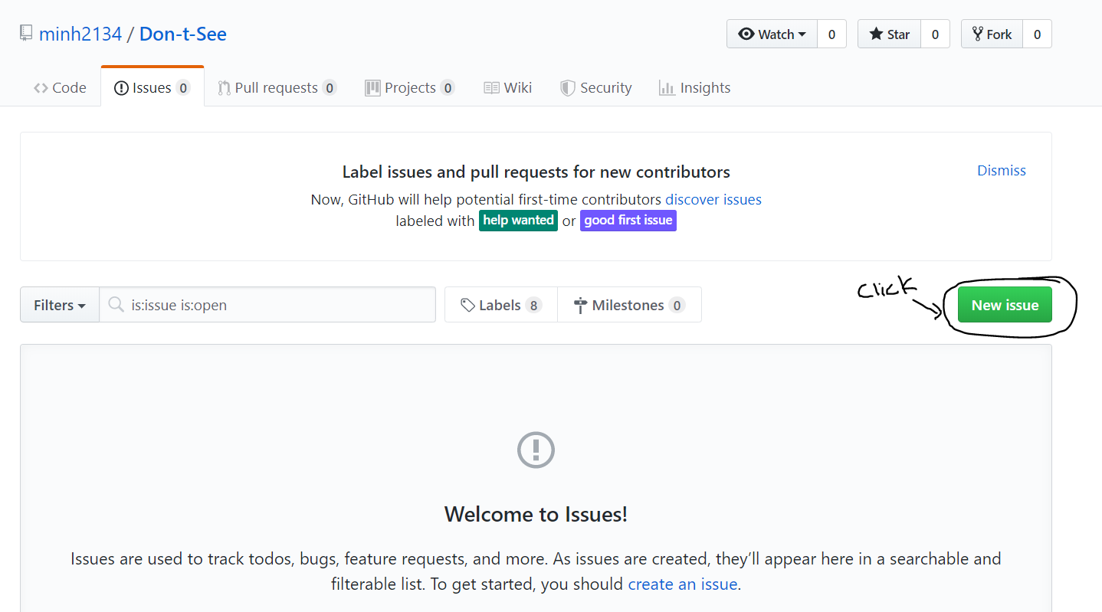

* Click on **New issue**
* Enter the title and comments about the problem
* Click on **Submit new issue**